BANK CHURN ANALYSIS
use bank;

select * from bank_data;
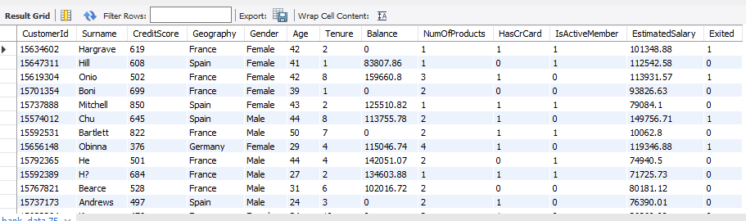

-- How many total customers are present in the dataset?
select count(*) as total_customers from bank_data;
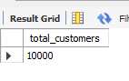
-- How many customers have exited the bank?
select count(*) as total_customer_exited from bank_data
where exited = 1;
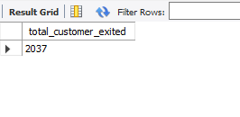

-- How many customers are still active (not exited)?
select count(*) as still_active from bank_data
where exited <> 1;
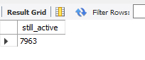

-- What is the average credit score of customers?
select avg(creditscore) as avg_credit_score from bank_data;
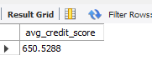
-- What is the minimum and maximum age of customers?
select min(age) as minimum_age, max(age) as maximum_age from bank_data;
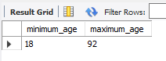

-- How many customers belong to each geography?
select geography, count(*) from bank_data
group by geography;
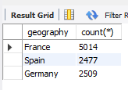

-- How many male and female customers are there?
select gender, count(*) as gender_count from bank_data
group by gender ;
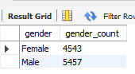

-- What is the average balance of all customers?
select avg(balance) from bank_data;
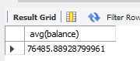

select avg(balance) from bank_data
where exited = 1;

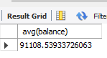
select gender, avg(balance) from bank_data
group by gender;
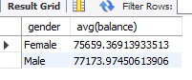

select gender, avg(balance) from bank_data
where exited = 1
group by gender;
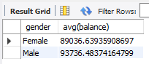

-- How many customers have a credit card?
select count(*) as total from bank_data;
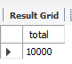
select count(*) as Exited from bank_data
where exited = 1;
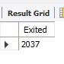
select gender, count(*) from bank_data
group by gender;
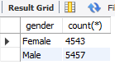

-- How many customers are active members of the bank?
select count(*) from bank_data
where isactivemember = 1;
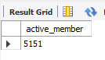

-- What is the average estimated salary of customers?
select round((EstimatedSalary),2) as Avg_Salary from bank_data;
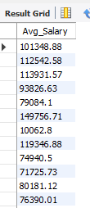

-- How many customers have more than one product?
select count(*) as more_than_one_product from bank_data
where NumOfProducts > 1;


-- What is the distribution of customers by tenure?
select Tenure,count(*) from bank_data
group by Tenure
order by Tenure;
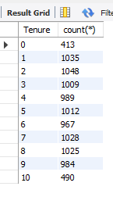
-- How many customers have zero balance?
select count(*) as zero_balance from bank_data
where balance = 0;


-- What is the average age of customers who exited?
select avg(age) as avg_age from bank_data;
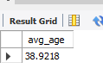
-- What is the average credit score of customers who exited vs those who stayed?
select case
when Exited = 1 then 'Exited '
else 'Stayed'
end as Exited, avg(CreditScore) as Avg_Credit_Score
from bank_data
group by exited;
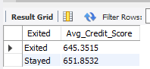

-- Which geography has the highest number of customers?
select Geography, count(*) as Highest_no_customer from bank_data
group by Geography
order by count(*) desc;
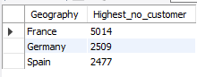

-- Which geography has the highest churn rate?
select Geography, count(*) as total_customer,
avg(Exited) * 100 as churn_rate
from bank_data
group by Geography;
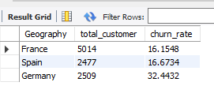
-- What is the average balance for customers in each geography?
select Geography, avg(Balance) as Avg_balance from bank_data
group by Geography;
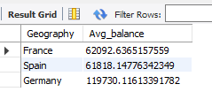
-- How does churn vary by gender?
select gender, round(avg(Exited) * 100 ,2) as churn from bank_data
group by gender;
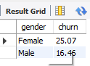

-- What is the average age of customers who exited vs those who stayed?
select case
when Exited = 1 then 'Exited '
else 'Stayed'
end as Exited, avg(age) as avg_age from bank_data
group by exited;
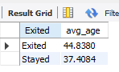
-- What is the average age of customers who exited vs those who stayed group by gender?
select case
when Exited = 1 then 'Exited '
else 'Stayed'
end as Exited, gender, avg(age) as avg_age from bank_data
group by exited, gender;
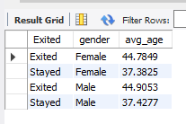

-- What is the average estimated salary by geography?
select geography,gender, round(avg(EstimatedSalary),2) as avg_salary from bank_data
group by geography,gender
order by geography;
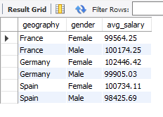
-- What is the churn rate for customers who have a credit card vs those who don't?
select case
when HasCrCard = 1 then 'Has a Card'
else 'No Card'
end as
HasCrCard,Gender, count(*),
count(*) * 100 / (select count(*) from bank_data) as Percentage from bank_data
group by HasCrCard, gender;
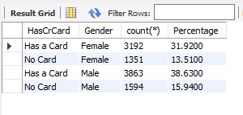
-- What is the churn rate for active vs inactive members?
select case
when IsActiveMember = 1 then 'Active Member'
else 'Non Active'
end as churn_rate,
count(*) * 100 / (select count(*) from bank_data) as churn_rate_in_Percent,
count(*) from bank_data
group by IsActiveMember;
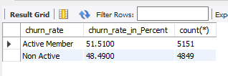

-- What is the average number of products used by exited customers?
select case
when Exited = 1 then 'Exited customer'
else 'not exited'
end as Exited_customer, avg(NumOfProducts) as avg_num_of_product from bank_data
where Exited = 1;


-- Which tenure group has the highest churn rate?
select Tenure, count(*) as churn,
count(*) * 100 / (select count(*) from bank_data where exited = 1) as churn_rate from bank_data
where exited = 1
group by tenure
order by tenure desc;
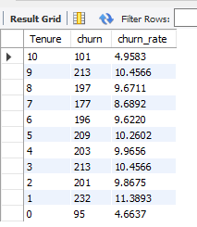

-- What is the average balance for male vs female customers?
select gender,avg(balance) as Avg_balance from bank_data
group by gender;
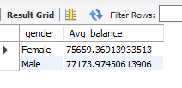
-- Which age group has the highest number of exits?
select case
when age >= 18 and age < 25 then 'Young Age'
when age >= 25 and age < 40 then 'Adult Age'
else 'Old Age'
end as Age_Group ,count(*) as Exited from bank_data
where exited = 1
group by Age_Group;
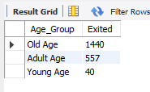

-- What is the average credit score by geography?
select geography, avg(CreditScore) as Avg_credit_score from bank_data
group by geography;
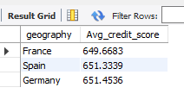

-- what is the average credit score by geography and by Age_group
with age_groups as (select case
when age >= 18 and age < 25 then 'Young Age'
when age >= 25 and age < 40 then 'Adult Age'
else 'Old Age'
end as Age_Group, CustomerID from bank_data)
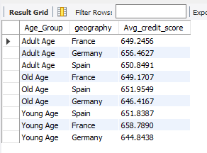

select a.Age_Group, b.geography, avg(b.CreditScore) as Avg_credit_score from bank_data b join
age_groups a on b.CustomerID = a.customerID
group by b.geography, a.Age_Group
order by a.age_group;
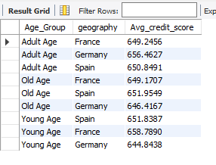
-- What percentage of customers have more than 2 products?
select NumOfProducts, count(*) * 100 / (select count(*) from bank_data) as percentage from Bank_data
where NumOfProducts > 2
group by NumOfProducts;
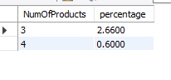
-- Find the top 10 customers with the highest balance.
select surname,
max(balance) over (order by balance desc) as max_balance from bank_data;
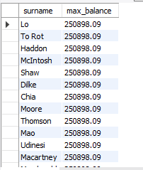

-- using window rank function
select surname, balance,
rank() over (order by balance desc) as ranking
from bank_data
limit 10;
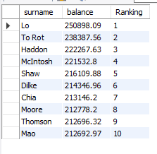
-- Find the average salary of customers grouped by geography and gender.
select geography, gender,round( avg(EstimatedSalary) ,2) from bank_data
group by geography, gender
order by geography;
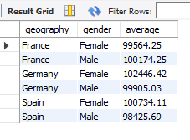
-- Identify customers whose credit score is below the average credit score.
select surname,
case
when CreditScore < 500 then 'Wrost'
when CreditScore between 500 and 700 then 'Good'
else 'Excellent'
End as Credit_Score from bank_data
where CreditScore < (select avg(CreditScore) from bank_data);
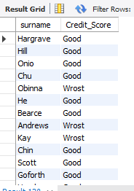

-- Rank customers based on their balance within each geography.
select * from (select surname,geography,
rank() over (partition by geography order by balance desc) as rank_by_salary
from bank_data) t
where rank_by_salary <=5;
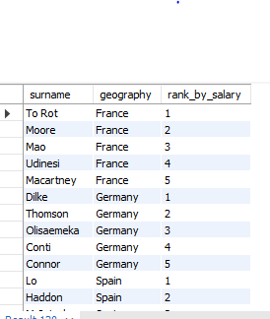

-- Find the top 5 customers with the highest estimated salary in each geography.
select * from (select surname, geography,
rank() over (partition by geography order by EstimatedSalary desc ) as High_salary
from bank_data) t
where High_salary <=5;
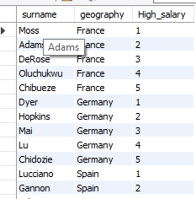

-- Calculate the churn rate for each age group.
with age_groups as (select CustomerId, case
when age >= 18 and age <= 25 then 'Young'
when age >= 26 and age <= 40 then 'Adult'
else 'Old'
end as Age_Group from bank_data)
select a.Age_Group,
count(*) as total_customer,
sum(b.Exited) as chruned_customer,
avg(b.Exited) * 100 as chruned_rate
from bank_data b
join age_groups a
on b.customerid = a.customerid
group by a.Age_Group;
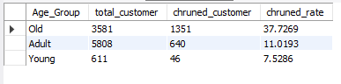

-- Find customers whose balance is greater than the average balance of their geography.
select customerid, surname, geography,balance from bank_data b
where balance > (select avg(balance) from bank_data where geography = b.geography);
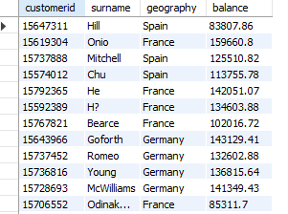
select customerid, surname, geography,balance from (
select *,
row_number() over (partition by geography order by balance desc) as rank_balance,
avg(balance) over (partition by geography ) as average_balance from bank_data
) t
where balance > average_balance and rank_balance <= 10;
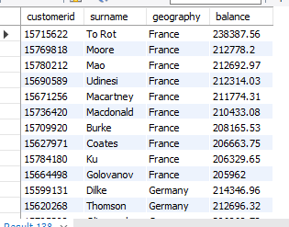

-- Find customers with the highest credit score in each geography.
select customerid,geography, CreditScore, surname from (
select *,
row_number() over (partition by geography order by CreditScore desc) as Hig_CR,
max(CreditScore) over (partition by geography) as maximum_CR
from bank_data
) ta
where Hig_CR <= 10;
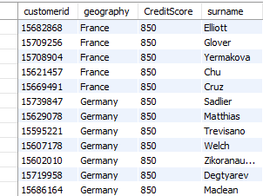

-- Identify customers who have more than 2 products but still exited.
select customerid,surname, NumOfProducts from bank_data
where NumOfProducts >1 and Exited = 1;

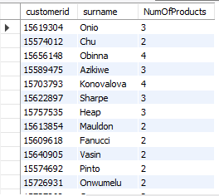

select NumOfProducts,
count(*) as total_customer,
sum(Exited) as total_exited,
avg(Exited) * 100 as churn_rate
from bank_data
group by NumOfProducts;
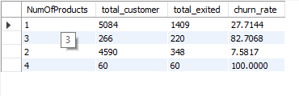
-- Find the average balance of the top 20% customers with the highest salaries.
select avg(balance) as average_balance
from (
select balance,
ntile(5) over (order by EstimatedSalary desc) as salary_group
from bank_data
) t
where salary_group = 1;
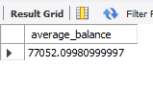

-- Find the percentage of customers who exited in each geography.
SELECT geography,
COUNT(*) AS exited_customers,
COUNT(*) * 100.0 / (
SELECT COUNT(*)
FROM bank_data b2
WHERE b2.geography = b1.geography
) AS exited_percent
FROM bank_data b1
WHERE exited = 1
GROUP BY geography;
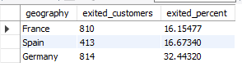

-- Rank customers by credit score within each gender.
select gender,customerid, surname,CreditScore, RowNumber, Rnk,DenseRnk from ( select *,
row_number() over (partition by gender order by CreditScore desc) as RowNumber,
rank() over (partition by gender order by CreditScore desc) as Rnk,
dense_rank() over (partition by gender order by CreditScore desc) as DenseRnk
from bank_data) t
where RowNumber <= 10;
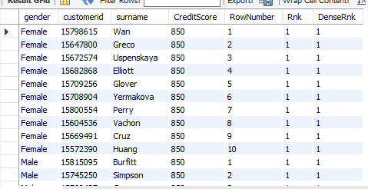

-- Identify customers whose salary is above the overall average salary but still exited.
select Distinct customerid, surname, EstimatedSalary, rnk from (
select *,
row_number() over (partition by exited order by EstimatedSalary desc) as rnk,
avg(EstimatedSalary) over (partition by Exited) as avg_salary from bank_data
) t
where EstimatedSalary > avg_salary and Exited = 1 ;
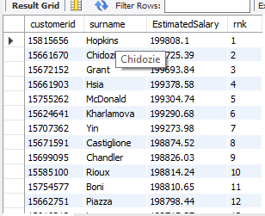

-- Find the top 3 age groups with the highest churn rate.
Select age_group,
count(*) as total_customer,
sum(Exited) as total_exited,
avg(Exited) * 100 as churn_rate from (
select *,case
when age between 18 and 25 then 'Young'
when age between 26 and 40 then 'Adult'
when age between 41 and 60 then 'Middle Age'
else 'Senior'
end as Age_group from bank_data
) t
group by Age_group
order by churn_rate desc
limit 3;
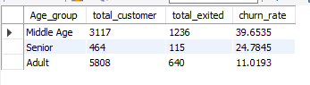

-- Calculate the cumulative balance of customers ordered by credit score.
select customerID, surname, geography,gender,age, creditScore, balance,
sum(balance) over (partition by geography order by CreditScore ) as Cumullative_balance
from bank_data;
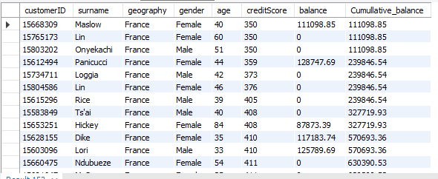

-- Find the top 5 customers with the highest balance in each geography.
select CustomerId, Surname, Geography, Balance from (
select *,
row_number () over (partition by geography order by balance desc) as rnk
from bank_data
) t
where rnk <= 5;
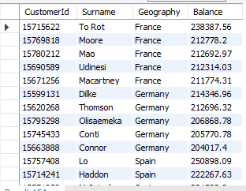

-- Find customers whose balance is greater than the average balance of their geography.
select CustomerId, Surname, Geography, Balance, avg_balance from (
select *,
row_number() over (partition by Geography order by Geography) as rnk,
avg(balance) over (partition by geography order by Geography) as avg_balance
from bank_data
) t
where balance > avg_balance and rnk <= 10;
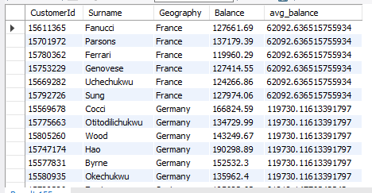

-- Rank customers within each geography based on their credit score.
select CustomerId, Surname, Geography, Balance CreditScore, ro from (
select *,
row_number() over (partition by Geography order by CreditScore desc) as ro,
rank() over (partition by Geography order by CreditScore desc) as rnk,
dense_rank() over (partition by Geography order by CreditScore desc) as dens
from bank_data
) t
where ro <= 10;
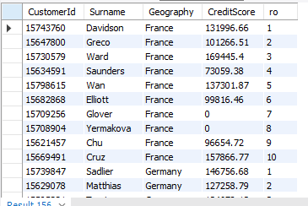

-- Calculate the running total of balance ordered by credit score.
select customerID, surname, geography,gender,age, creditScore, balance,
sum(balance) over (partition by geography order by CreditScore ) as Cumullative_balance
from bank_data;

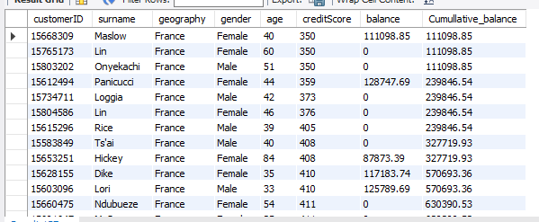

select
Geography,
Gender,
case
when Age between 18 and 25 then 'Young'
when Age between 26 and 40 then 'Middle Age'
when Age between 41 and 60 then 'Adult'
else 'Senior'
end as Age_Group,

COUNT(*) as Total_Customers,
SUM(Exited) as Churned_Customers,

ROUND(Avg(Exited) * 100.0 ,2) as Churn_Rate
from bank_data
group by Geography, Gender, Age_Group
order by Churn_Rate desc;

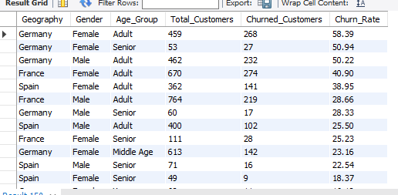

SUMMERY :
The document performs SQL-based analysis on a bank customer dataset (bank_data) to understand customer behavior and churn (customers leaving the bank). It uses aggregations, CASE statements, CTEs, and window functions to extract business insights.
DATASET OVERVIEW
- CustomerId
- Surname
- CreditScore
- Geography
- Gender
- Age
- Tenure
- Balance
- NumOfProducts
- HasCrCard (Yes = 1, No = 0)
- IsActiveMember (Yes = 1, No = 0)
- EstimatedSalary
- Exited (Yes = 1, No = 0)
Customer Demographics & Status: It determines the total number of customers , counts how many have exited vs how many remain active , and breaks down the customer base by geography and gender. It also identifies the minimum and maximum ages of the customers.
Financial Profiling: The queries calculate average credit scores, average account balances, and average estimated salaries. These financial metrics are further analyzed by grouping them by gender, geography, and whether the customer has exited or stayed.
Product Engagement: The analysis looks at customer engagement by counting how many customers possess a credit card, how many are considered active members, and how many utilize more than one bank product.
Churn Drivers: A significant portion of the document focuses on identifying churn rates across different segments. It examines how churn varies by geography , gender , credit card ownership , active membership status , and tenure groups. It also investigates which age groups have the highest number of exits.
Advanced Ranking and Segmentation: Using window functions, the analysis ranks top customers based on their balances and credit scores within specific geographic regions and genders. It also identifies specific customer profiles, such as customers with above average salaries who still chose to exit the bank.

